I need to stay home if…
 |  |  |  |  |  | 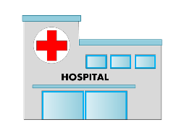
FEVER | VOMITING | DIARRHEA | RASH | HEAD LICE | EYE INFECTION | HOSPITAL STAY AND/OR ER VISIT
Temperature of 100.4 or higher | Within the past 24 hrs. | Within the past 24 hrs. | Body Rash with itching or fever | Itchy head, active head lice | Redness, Itching, and/or “crusty” drainage from eye | Hospital stay and/or ER Visit
I AM READY TO GO BACK TO SCHOOL WHEN I AM…
Fever free for 24 hrs. without the use of fever reducing medication i.e. Tylenol, Motrin | Free from vomiting for 24 hrs. | Free from diarrhea for at least 24 hrs. | Free from rash itching, or fever. I have been evaluated by my doctor if needed. (Also at Director’s Discretion) | Treated with appropriate lice treatment at home and proof is provided to nurse. | Evaluated by my doctor and have note to return to school (Also at Director’s Discretion) | Released by medical provider to return to work or school.

